Artist Brief – Expression of Interest
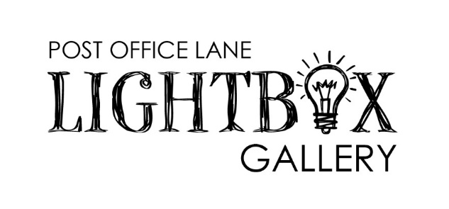

With this Artist Brief, the City of Greater Geraldton (‘The City’) is seeking Expressions of Interest to commission an Artist or Artist(s) to showcase their work in the Post Office Lane Lightbox Gallery.

The aim of the Lightbox Gallery is to provide a public exhibition space to showcase local Artists and provide the community with an accessible gallery.

This opportunity is open to Artists of all ages and experience levels, as well as community groups or curators of group exhibitions. Applications must be submitted through the online application form by the closing date provided – see section 6.

The following Site Context and Design/Other considerations are important in developing the Expression of Interest (EOI).

SITE CONTEXT

As part of the Rocks Laneway Redevelopment, the City is excited to present the Post Office Lane Lightbox Gallery, Geraldton’s newest public exhibition space.

Eight lightboxes are located in the laneway at Post Office Lane, Geraldton with exhibitions running for a minimum of 8 weeks.

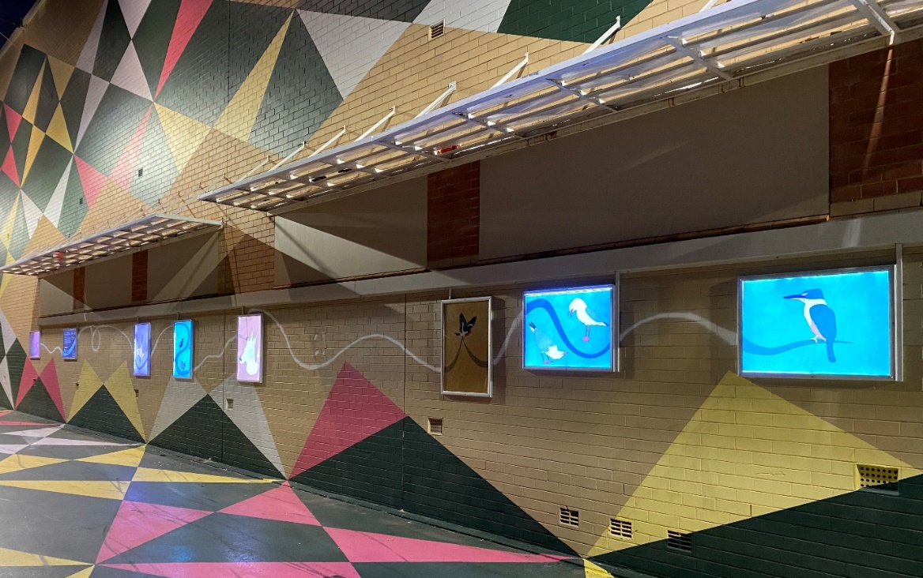

Post Office Lane Lightbox Gallery Exhibition by Sara Walker.

DESIGN AND OTHER CONSIDERATIONS

- Your artwork must be supplied ready for print in high resolution digital format (PDF):
- All of the files need to be set on 594mm X 841mm.
- Proposed artworks must be original creative works.
- Given the artwork’s location within a public open space, the artwork should be appropriate for audiences of all ages. This includes artworks that are not deliberately provocative or offensive and the artwork contains no overt sexual content.
- Preference will be given to Artists residing in the Midwest Region.
- The City’s Community and Public Arts Officers will install works. The artwork will be removed when the next exhibition is installed, and the Artist may keep the prints.
- Proposals are to address all 8 lightboxes with four being portrait and four being landscape.
- Please note that images will be cropped if they don’t fulfill the size specified.
- The City reserves the right to not proceed to commission a work from this expression of interest.

Post Office Lane Lightbox Gallery Exhibition Plan:
Please note:
- Successful applicants will be required to supply their final exhibition images numbered in order of installation. If artwork images are not labelled according to installation order, you grant the City permission to install your artwork in random order.
- We recommend dedicating one (1) lightbox to Artist information, an opportunity to direct the community on where to find out more about you and how to purchase artworks.
- The timing of the exhibitions will be determined by the Geraldton Regional Art Gallery Team.

SELECTION PROCESS

Stage 1 – EOI Open Call
- Artist submissions of EOI.
- No fee is associated with EOI submissions.

Stage 2 – Selection and commission
- The EOI’s from Stage 1 will be presented to a panel of up to three (3) representatives from the Geraldton Regional Art Advisory Committee (GRAAC) for review and selection.
- The selection will be subject to final approval by the GRAAC.
- An Artist’s Agreement will be issued to the successful Artist/s.
- A fee will be paid to the successful Artist/s – see Section 4.

FEES

Stage 1 – EOI Open Call
- No fee is associated with EOI submissions.

Stage 2 – Selection and Commission
- The commission is $1,000 (Inc GST)

The successful Artist is expected to cover -

This budget should cover all costs related to the development and presentation of the work, including Artist fees, materials and costs associated with digitising the artwork ready for print.
The City will organise and pay for printing of the digital artworks on non-adhesive transparency film ready for installation. The City will provide marketing support by way of advertising on CGG/GRAG website, newsletter and social media.

- The Artist Agreement shall contain requirements for ensuring the artwork is fit for purpose in a public open space and shall not expose the public to undue risk.

- Prior to payment, the selected artist will also be required to provide a Tax Invoice to the City of Greater Geraldton stating the Artist’s ABN or providing a signed Australian Tax Office Statement by Supplier form, no later than 14 days after receipt of the signed Artist Agreement.

SELECTION CRITERIA
Proposals should respond to the space in a contemporary manner. Applications will be assessed based on:

Stage 1 – EOI Open Call
Selection Criteria | Submission Requirement | Evaluation Weighting
Respondent Details | Artist/s name, contact details | N/A
Response to the brief | Provide a brief description of your proposed exhibition supported by conceptually resolved visual mock up. | 30%
Artistic excellence and Originality | Demonstrated ability to execute artworks that exhibit artistic quality, are original, have visual impact and presented to a professional standard. | 70%

DUE DATES

Stage 1 – EOI Open Call
- The Expression of Interest (EOI) should be submitted through the online application form by Close of Business (C0B), 5:00pm Friday 9 February 2024.

Stage 2 – Selection and Commission
- The selected Artist/s will be notified by email by Friday 1 March 2024 on their successful EOI application.
- The commission of works will be discussed with the successful Artist/s once they have been notified.

COPYRIGHT AND INSURANCE

The City reserves the right to document, or otherwise use any artwork submitted for Lightbox Gallery for purposes associated with Lightbox Gallery, without charge. The City will acknowledge the Artist as the author of the Artwork and recognise the Moral Rights of the Artist in accordance with the Copyright Act 1968.
The Artist agrees that the copyright in all artworks created in the course of the contract remain the property of the Artist. The Artist shall give the City a non-exclusive Licence to reproduce the images for related non-commercial purposes including publicity and promotion of the event/project, education and record keeping.
The City takes no responsibility for damage or loss of any kind to artworks, including vandalism and theft.

FURTHER INFORMATION
Questions about this brief can be directed to: Marnie Facchini, Community and Public Arts Officer. Email: marnief@cgg.wa.gov.au Ph: (08) 9956 6968

