INFORMATION FOR EXPRESSIONS OF INTEREST
NEXT ROUND: KEY DATES
EXHIBITION DATES | ENTRIES OPEN | ENTRIES CLOSE | APPLICANTS NOTIFIED | DIGITAL ART DUE
29 June 2022 – 3 October 2022 | 29 April 2022 | 20 May 2022 | 26 May 2022 | 24 June 2022

Public art plays an important role in enhancing and complementing our environments, it brings communities together, offers social and educational opportunities and promotes tourism. The aim of the Lightbox Gallery is to provide a public exhibition space to showcase local artists, and provide the community with an accessible gallery. It will also serve as an exciting feature of Post Office Lane, connecting Geraldton Regional Art Gallery with the new town square and Rocks building.
Eight lightbox cabinets are located in the laneway at Post Office Lane, Geraldton with exhibitions running for a minimum of 8 weeks. We recommend dedicating 1 lightbox to artist information, and directing the community to purchase your works and to find out more about you.
Proposals should be conceptually resolved and supported by a visual mock up alongside examples of past works and submitted through the online application form by the closing date provided. Preference will be given to artists residing in the Midwest.

LIGHTBOX DIMENSIONS
Proposals are to address all 8 lightboxes with four being portrait, and four landscape. Artwork inserts are printed at a trim size of roughly A2 (596mm x 422mm) with a display area of 574 x 400mm.

SUPPLY OF ARTWORK
Your artwork must be supplied ready for print in high resolution digital format (PDF):
Trim Area 596 X 422mm
Display Area 574 X 400mm

INSTALLATION
The City’s Community and Public Arts Officer will install works. The artwork will be removed when the next exhibition is installed and the artist may keep the prints.

THE COMMISSION
Proposals should respond to the space in a contemporary manner. Applications will be assessed based on:
- the exhibition rationale;
- demonstration of artistic excellence and innovation of the works proposed; and
- quality of previous artworks (supported by image submission).
All artwork and imagery is to be G rated and to contain no offensive material.

BUDGET
The commission is $1,000 (ex GST)
This budget should cover all costs related to the development, marketing and presentation of the work, including artist fees, materials and costs associated with digitising the artwork ready for print.
The City will organise and pay for printing of your digital artwork on non-adhesive transparency film ready for installation. The City will provide marketing support by way of advertising on CGG/GRAG website, newsletter and social media.

COPYRIGHT AND INSURANCE
The City reserves the right to document, or otherwise use any artwork submitted for Lightbox Gallery for purposes associated with Lightbox Gallery, without charge. The City will acknowledge the Artist as the author of the Artwork and recognise the Moral Rights of the Artist in accordance with the Copyright Act 1968.
The Artist agrees that the copyright in all artworks created in the course of the contract remain the property of the Artist. The Artist shall give the City a non-exclusive Licence to reproduce the images for related non-commercial purposes including publicity and promotion of the event/project, education and record keeping.
The Artist warrants that the Artworks and any Intellectual Property supplied by the Artist and embodied or used in connection with the Artwork is the sole property of the Artist or the Artist is legally entitled to use the Intellectual Property for the provision of the Artwork.

ENQUIRIES
All enquiries should be directed to the City’s Community and Public Art Officer on (08) 9956 6968 or email rachaelv@cgg.wa.gov.au
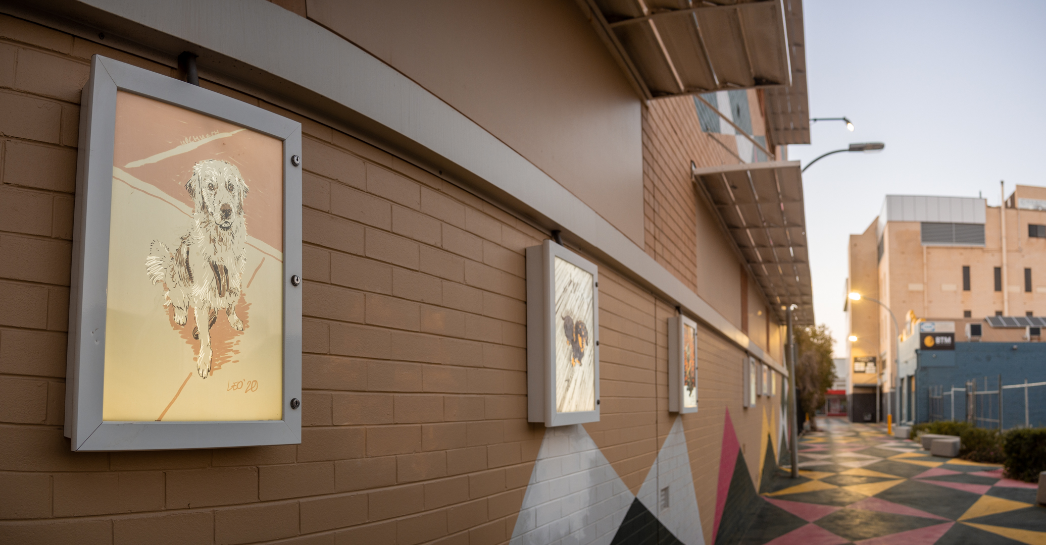
Post Office Lane Lightbox Gallery Artwork by: William Upchurch. Photo by: The Artist.

POST OFFICE LANE LIGHTBOX GALLERY EXHIBITION PLAN

ARTWORK DIMENSIONS
All of the files need to be set on 596mm x 422mm, high resolution digital format (PDF).
