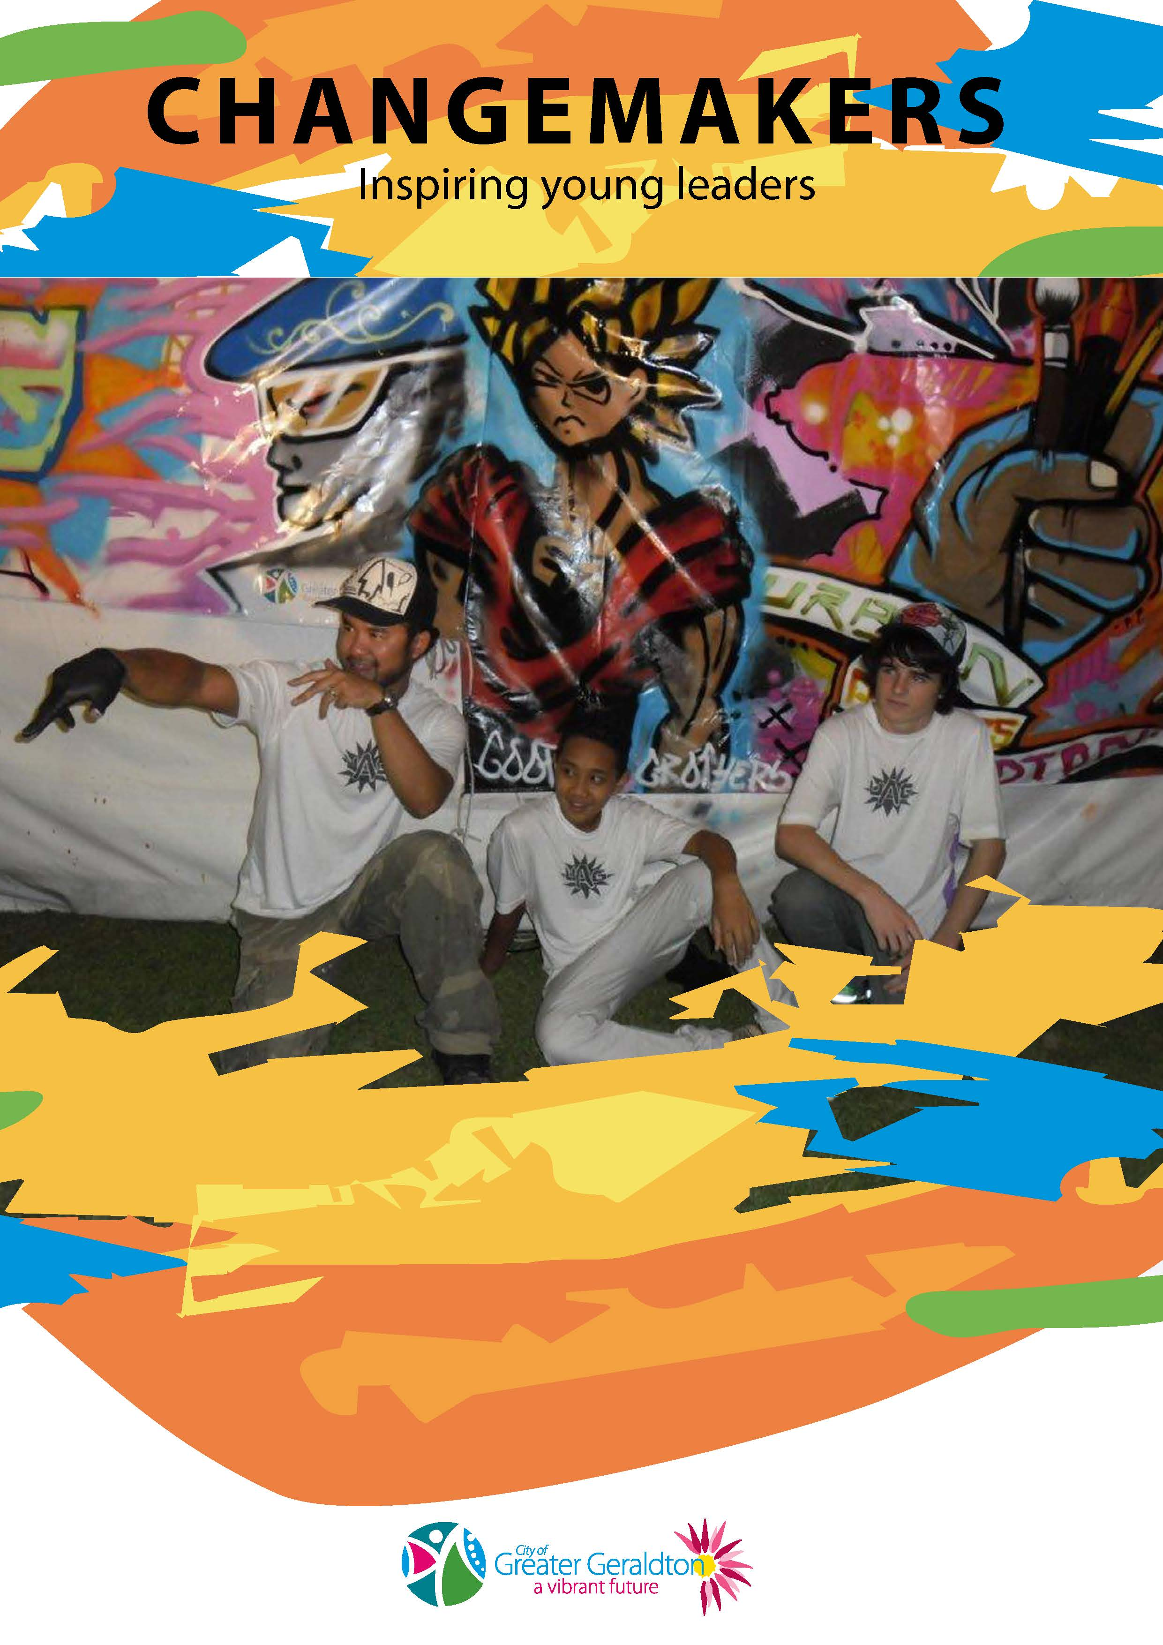

CHANGEMAKERS

CHANGEMAKERS aims to encourage and support young people to become more confident and active community members through their participation in young person led project work or professional development.
The CHANGEMAKERS program is available for youth aged 12 to 18 years
Introduction
The CHANGEMAKERS program gives youth who wish to develop a project or increase personal skill levels access to some funding and guidance to make their project happen.
The program involves youth creating their project, with support from a youth worker from a community organisation who would be their mentor for the project. The Youth Project Team develop their idea by obtaining a list of the costs, people and resources needed to make it happen and present the idea to a panel (similar to a job interview).
Once the project is ready for presentation to seek funding the mentor would contact the City of Greater Geraldton Youth Development Officer on 9956 6600 to set up a meeting.
The Youth Development Officer would arrange for two people to be available to visit the Youth Project Team at their chosen venue to hear about their project and would be able to make a decision as to the amount of funding available for the project.
The organisation supporting the youth can then invoice the City of Greater Geraldton and the funds will be transferred and the project can proceed.
One of the panel members will keep in touch with the Youth Project Team during the project to give any additional support as needed.
At the end of the project the Youth Project Team will be required to give a report back to the City of Greater Geraldton, through the organisation supporting them, which will consist of a brief report and the budget including supporting receipts. This is an opportunity for the Youth Project Team to be creative and provide photos and other ways of reporting the success of their project. It can also be arranged for them to make a presentation to City of Greater Geraldton Mayor and Councillors if they wish.

KEY ROLES IN CHANGEMAKERS PROGRAM:

Applicant: Youth project team
Host Organisation: Organisation which supports the youth project team
Mentor: Key youth worker who works with the youth project team
Project Panel: Consists of two members with at least one being a City of Greater Geraldton officer

KEY OBJECTIVES
- Enhance young people’s self-esteem.
- Connect young people to their peers and community.
- Develop the TLC (teamwork, leadership and communication) skills of young people.
- Engage young people in active contribution to community.
- Develop project management skills

FUNDING

CHANGEMAKERS funding for 2014/15 is $2,000. Applications will be assessed in order of lodgement until pool of funds is exhausted.

LEVEL 1 – Individuals and Groups
$100 – $500 Projects show evidence of bringing about personal development and learning opportunities for the group. The proposal also show evidence of significant planning eg community workshop on certain skills, activity, coaching.
LEVEL 2 - Groups
$500 – $1,000. Projects show evidence of planning and also clearly defined community benefit ie. benefits a wider group than the project team.

SKILLS IN FOCUS
The CHANGEMAKERS program, with its emphasis on ‘Young Person Led Community Projects’ aims to develop skills relevant to the workforce which also contributes to community life.
The skills in focus are:
- Working effectively in a team
- Assessing strengths & weaknesses
- Seeking information and advice
- Decision making
- Planning projects
- Carrying through responsibilities
- Developing negotiating skills with peers and external service providers
- Problem solving
- Resolving conflict
- Coping with stress and tension
- Evaluating own and teams performance
- Developing communication skills to give and take feedback
- Developing presentation skills
- Building relationships with community
Please forward applications marked “CHANGEMAKERS Application” to:

POST: Coordinator Community Development DELIVER: Coordinator Community Development City of Greater Geraldton City of Greater Geraldton
PO Box 101 Cathedral Avenue
GERALDTON WA 6531 GERALDTON WA 6530

EMAIL: yvonnel@cgg.wa.gov.au
HINTS FOR A SUCCESSFUL PROJECT TEAM
HOW you provide the Project Panel with information about your application for funding is up to your IMAGINATION!
Here are some useful questions you should consider when putting together the information for the panel.
Your mentor can help you in answering them!
- What is your project name?
- How much money are you applying for?
- Does it fit one of the 2 levels of the Project Fund Guidelines?
- Which level?
- How can you demonstrate that the idea has come from your team? That the ideas are yours and not someone else’s!
- How would you describe your project? What are you going to do?
- How many young people are involved in your project?
- What have you done in your project so far?
- How can you show that your “learning has earnt the grant?” Which Teamwork, Leadership and Communication skills have you used?
- Is the project
- Safe? Yes □ No □
- Legal? Yes □ No □
- Realistic? Yes □ No □
- What else can you say, do, or show about your project?

Application Form (Guide Only)

Contact Name: …………………………………………...………………………

Address: …………………………………………………………………………..
Phone No: ……………………………..………………………………………….
Age: ……………………………………………..

Names of other young people helping: …………………………………………………………………………………………………………………………………………………………………………

Name/Address/Telephone number of your support organisation and mentor (e.g. teacher): ……………………………………………………………………………………………….…..…….……………….……….………………………………………

1. Describe your activity...
• What do you want to do? (eg. dj workshop)
……………………………………………………………………………………
• Why do you want to do it? (eg. Fun, learn skills)
……………………………………………………………………………………
• How will you do it? (eg. Hire a DJ, advertise)
……………………………………………………………………………………
• Where will it happen? (eg. Name of the place) ………………………………..
• What age group are you targeting? ……………………………………………
• When will it happen? …………………………………………………………..
• Who else will be involved?(e.g. your school) …………………………………..
• How many people will it involve? ………………………………………………

2. How much money are you asking from Changemakers? ……………………

3. Write out a budget (attach a separate page if necessary)
INCOME (List items) | Amount | EXPENDITURE  (list items) | Amount
TOTAL |  | TOTAL

4. Will you need some extra help to run it? ……………………………………

Budget Form (Guide Only)

REMEMBER:
Keep all your receipts of money spent.
Return the receipts with the Evaluation Form on completion of your activity.

Things to consider when you work out a budget:

Hire of a hall or venue $…………….
Hire of equipment $…………….
Food $…………….
Drinks $…………….
Advertising: Posters, leaflets $…………….
(Photocopying, fluoro paper)
Transport (fuel, hire van) $…………….
Cleaning $…………….
(Rubbish bags, cleaning stuff)
Security Guards $…………….
Conference Registration $…………….
Accommodation $…………….
TOTAL $…………….

Float: Notes: $ 10.00
$ 5.00
Coins: $ 2.00
$ 1.00
50c
20c
10c
TOTAL: $…………….

Other: $…………….

Do you have enough money?

CHANGEMAKERS PROJECT ACQUITTAL
Once project is finalised, please complete this form, attach copy of budget for the project and return to:

Coordinator Community Development
City of Greater Geraldton
P O Box 101
GERALDTON WA 6531

DETAILS OF YOUR PROJECT |  | Organisation
 |  | Project Name
 |  | Grant amount
 |  | Date of Completion
HAVE THE EXPECTED OUTCOMES BEEN ACHIEVED? (Please refer to the Terms and Conditions / Key Results as stated in your Letter of Agreement and give details as to how they were achieved)

WHAT YOUTH PARTICIPATION / BENEFITS HAVE OCCURRED AS A RESULT OF THE PROJECT TO DATE?

HAS THERE BEEN ANY CHANGES TO THE PROJECT’S OBJECTIVES, TIMELINE, BUDGET AND / OR ALLOCATION OF THE CITY’S FUNDING |  | Objectives/Outcomes
 |  | Timeline
 |  | Overall Budget
 |  | City’s Funding allocation
WHAT ACKNOWLEDGEMENT HAS THE CITY OF GREATER GERALDTON RECEIVED AS A RESULT OF THIS SPONSORSHIP? (Please provide evidence to support this e.g. newspaper articles, newsletters, advertising brochures etc.)

FINANCIAL STATEMENT
Please supply total project details for this event / activity / program
(Include receipts, invoices etc. for verification of the City’s expenditure).
All amounts are to be exclusive of GST.

INCOME |  | BUDGET | ACTUAL  (To Date) | VARIATION (Budget less Actual)
CASH SOURCES
City of Greater Geraldton |  | $ | $ | $
Applicant Cash |  | $ | $ | $
 |  | $ | $ | $
 |  | $ | $ | $
 |  | $ | $ | $
 |  | $ | $ | $
 |  | $ | $ | $
TOTAL CASH INCOME | A | $ | $ | $
IN KIND SOURCES
Applicant In Kind |  | $ | $ | $
 |  | $ | $ | $
 |  | $ | $ | $
 |  | $ | $ | $
TOTAL IN KIND INCOME | B | $ | $ | $
TOTAL INCOME (A + B) | C | $ | $ | $
EXPENDITURE (Marked items are to be covered by CGG Sponsorship and copies of invoices / receipts to be supplied for verification of expenditure)
CASH FUNDS EXPENDED
 | ☐ | $ | $ | $
 | ☐ | $ | $ | $
 | ☐ | $ | $ | $
 | ☐ | $ | $ | $
 | ☐ | $ | $ | $
 | ☐ | $ | $ | $
 | ☐ | $ | $ | $
 | ☐ | $ | $ | $
 | ☐ | $ | $ | $
TOTAL CASH EXPENDITURE | D | $ | $ | $
IN KIND EXPENDITURE
Project Management / Administration |  | $ | $ | $
Printing / Postage / Phone |  | $ | $ | $
Volunteers |  | $ | $ | $
 |  | $ | $ | $
 |  | $ | $ | $
 |  | $ | $ | $
TOTAL IN KIND EXPENDITURE | E | $ | $ | $
TOTAL EXPENDITURE (D + E) | F | $ | $ | $
NET SURPLUS / (DEFICIT) (C – F) | G | $ | $ | $
Note: Volunteer staff can be costed at $20 / hour

DECLARATION

I, the undersigned, certify that I have been authorised to submit this Project Acquittal and that the information contained herein and attached is to the best of my knowledge true and correct.

Name: |  | Position Held:
Signed: |  | Date:

Please forward completed Acquittals marked “Changemakers Project Acquittal” to:

POST: Coordinator Community Development DELIVER: Coordinator Community Development City of Greater Geraldton City of Greater Geraldton
PO Box 101 Cathedral Avenue
GERALDTON WA 6531 GERALDTON WA 6530

EMAIL: yvonnel@cgg.wa.gov.au

